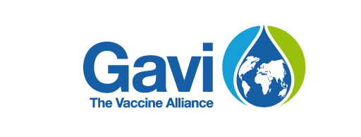

Innovation Top-up Narrative Template for “standalone” requests

- The request to access Gavi support will need to be endorsed by the Minister of Health, or their delegated authority.
- The completed request, together with supporting documents must be submitted to Gavi by e-mail to proposals@gavi.org, copying the Senior Country Manager, by one of the published IRC submission deadlines, i.e. 17 January, 18 April, 18 July or 3 October 2023.
- Following submission, the request will be tabled for review at the next meeting of the Independent Review Committee (IRC).

COUNTRY REQUEST & SUPPORTING INFORMATION

Country
Ministry
Contact details of the country focal point for this request | Name:  Email:  Telephone:

Country needs
- Please describe the specific problem(s) you are facing and trying to address through this request, the specific needs you have and the current funding gap.

Proven interventions to be scaled up
- Please describe the proven intervention(s) you want to scale-up? Is/are this/these intervention(s) highlighted in the PFG as an innovative intervention? Is/are this/these intervention(s) already implemented and proven in the country or other countries you are aware of?

Country ownership
- Is/are the intervention(s) proposed to be scale-up with the Innovation top-up also supported by the Gavi HSS, campaign operational support (Ops) grant and/or domestic fund and/or other donors’ funding and highlighted in a national costed roadmap with a sustainability & transition plan?

Existing Gavi funding absorption
- Has the possibility to reallocate existing funding, e.g. Gavi HSS funding been fully explored before requesting a top up/gap funding? Please elaborate.

Budget
- What is the total budget amount requested for the innovation top-up?
- From the total request, what is the budgeted amount foreseen for operational cost for interventions and enabling environment (maximum 85%)?
  - Who is going to be the fund recipient?
- From the total request, what is the budgeted amount foreseen for technical assistance (maximum 15%):
  - Who is going to be the partner(s) providing the technical assistance? Is it a new or existing partner?

Learning agenda
- What is planned and budgeted for the learning agenda of that innovation?

Timeline
- By when the implementation and learning agenda will be completed?

ATTACHMENTS & SUPPORTING DOCUMENTS

Mandatory supporting documents:
Please ensure the following documents are provided together with this form to support your request:
- Workplan, in the dedicated instructions & workplan template for stand-alone Innovation Top Up requests
- Budget, in Gavi Budgeting & Reporting Template
  - Please refer to the Gavi Budgeting & Reporting Template User-guide & Gavi Budget Eligibility Guide
- Endorsement of the request by coordination body, e.g. Immunization Inter-Agency Coordination Committee (ICC) minutes
- Signature by the Minister of Health (or delegated authority), using the dedicated sheet in the instructions & workplan template for stand-alone Innovation Top Up requests

You may also attach any other supporting documents pertinent to the request (e.g. existing documents on an innovation to be expanded).

