TEMPLATE

Strategic Narrative for Gavi Support Request

Use this template to show how the support you are requesting from Gavi will help you realise your Theory of Change.

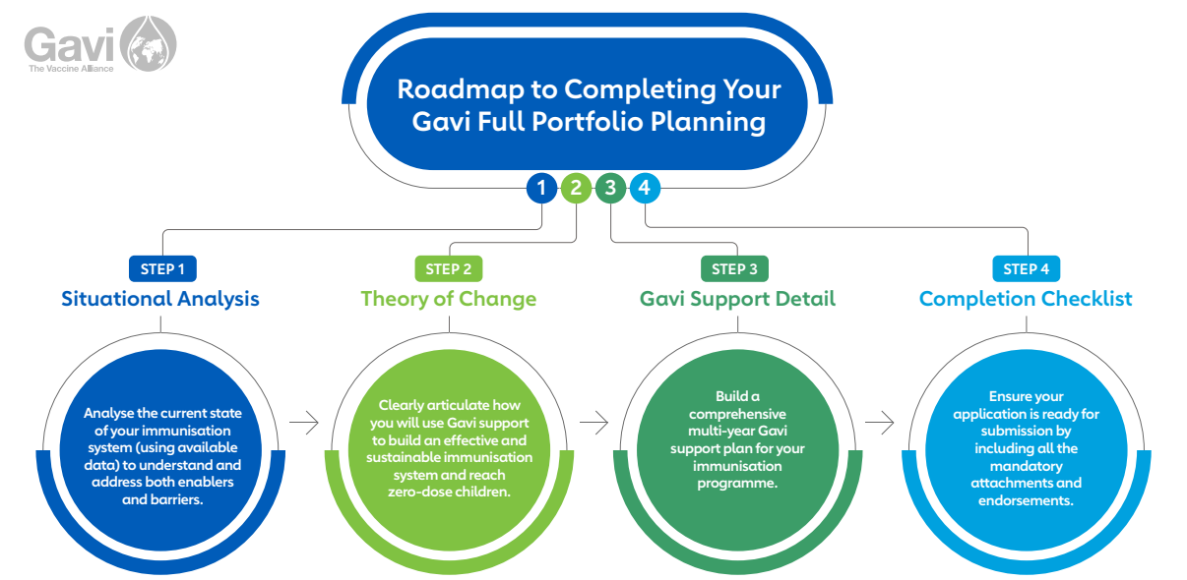

- What vision / goals would you like to achieve over the course of the period covered by your Theory of Change and the funding request to Gavi?
  - How do these goals link to your National Immunisation Strategy (NIS) or other country, sub-national, regional, or global plans (IA 2030)?

Please enter your response here:

- How did you prioritise intervention areas for your Theory of Change based on your situational analysis?
  - Which barriers/enablers to reaching zero-dose, under-immunised, and missed communities have been prioritised for interventions?
  - What was the rationale for prioritising these barriers/enablers for Gavi support? Please reflect, as appropriate, additional support - both funding and operational - available to you from partners, CSOs, and other donors, and synergies with other government initiatives/donor support.
  - What criteria were used to prioritise sub-national areas? (If available, provide a mapping of the prioritised intervention areas. Targeted areas must also be indicated in the Gavi Support Detail in the Targeted Areas tab.)

Please enter your response here:

- What were the lessons learned from your most recent HSS grant that should be taken into consideration for the programming of the newly requested support?
  - How are these learnings incorporated into this current request?
  - Are there any recent changes in the country context that are significant to understanding the country vision and Gavi support request?

Please enter your response here:

- Please elaborate how you will improve your coverage of zero-dose children and missed communities.

4a: Aspects related to Introduce & Scale / Expand & Reach
  - How will you target support provided by Gavi to specific geographies and sub-populations to reach zero-dose children and missed communities?
  - How will you tailor approaches for reaching zero-dose children and missed communities in different geographies or populations appropriate to your context (e.g., urban settings, conflict/fragile, remote rural, etc)?
  - If applicable, how will you use new vaccine introductions and campaigns planned during this period to further target zero-dose and missed communities and to enhance inclusion of these groups within routine immunisation programmes?
  - What are your strategies to engage caregivers and communities from the missed communities? What local influencers, advocacy, partnerships, and communication channels are necessary to identify and reach these communities?
  - How are the suggested strategies considering gender-related barriers to immunisation?

Please enter your response here:

4b: Aspects related to Manage, Monitor & Learn / Commit & Sustain
  - Where are the opportunities to integrate efforts [within the immunisation context, with other health interventions (e.g., nutrition), or non-health actors (e.g., agriculture, education, water & sanitation)]?
  - What are some innovative strategies or elements that will be supported by this grant?
  - Have you conducted a partner mapping and which partners have you identified - including Alliance and expanded partners, local partners and CSOs, FBOs, and CBOs - to support activity implementation?
  - Are national and subnational stakeholders committed to prioritising zero-dose and missed communities and a part of the planning process? Are these commitments reflected in policies, planning, budgets, and coordination? Is an advocacy strategy needed to secure such commitment?

Please enter your response here:

- Please elaborate on how the different types of Gavi support complement each other.
  - If you are applying for EAF: How will the EAF grant build on the HSS support being requested or already programmed?
  - How are health system strengthening investments supporting anticipated new vaccine introductions, switches, or campaigns? How will vaccine introductions and/or campaigns contribute to health system strengthening?
  - How are other types of Gavi support (such as PEF-TCA and CCEOP) complementing each other and contributing to your Theory of Change and goals?
  - If you are requesting an Innovation Top Up, what is the reason for requiring a top up and how will the activities be sustained?
  - How did you consider other support, as applicable?

Please enter your response here:

